PRACTICAL NO.7
Programs on Intents, Events, Listeners and Adapters
The Android Intent Class, Using Events and Event Listeners
Code:
activity_main.xml
<?xml version="1.0" encoding="utf-8"?>
<androidx.constraintlayout.widget.ConstraintLayout xmlns:android="http://schemas.android.com/apk/res/android"
xmlns:app="http://schemas.android.com/apk/res-auto"
xmlns:tools="http://schemas.android.com/tools"
android:layout_width="match_parent"
android:layout_height="match_parent"
tools:context=".MainActivity">
<EditText
android:id="@+id/user_data"
android:layout_width="match_parent"
android:layout_height="wrap_content"
android:layout_marginStart="32dp"
android:layout_marginEnd="32dp"
android:ems="10"
android:hint="User data"
android:inputType="textPersonName"
app:layout_constraintBottom_toBottomOf="parent"
app:layout_constraintEnd_toEndOf="parent"
app:layout_constraintHorizontal_bias="0.402"
app:layout_constraintStart_toStartOf="parent"
app:layout_constraintTop_toTopOf="parent"
app:layout_constraintVertical_bias="0.069" />
<Button
android:id="@+id/button"
android:layout_width="wrap_content"
android:layout_height="wrap_content"
android:text="Submit"
app:layout_constraintBottom_toBottomOf="parent"
app:layout_constraintEnd_toEndOf="parent"
app:layout_constraintHorizontal_bias="0.899"
app:layout_constraintStart_toStartOf="parent"
app:layout_constraintTop_toTopOf="parent"
app:layout_constraintVertical_bias="0.155" />
<Button
android:id="@+id/button2"
android:layout_width="wrap_content"
android:layout_height="wrap_content"
android:text="Go"
app:layout_constraintBottom_toBottomOf="parent"
app:layout_constraintEnd_toEndOf="parent"
app:layout_constraintHorizontal_bias="0.9"
app:layout_constraintStart_toStartOf="parent"
app:layout_constraintTop_toTopOf="parent"
app:layout_constraintVertical_bias="0.349" />
<EditText
android:id="@+id/url_text"
android:layout_width="match_parent"
android:layout_height="wrap_content"
android:layout_marginStart="32dp"
android:layout_marginEnd="32dp"
android:ems="10"
android:hint="Enter Url .."
android:inputType="textPersonName"
app:layout_constraintBottom_toBottomOf="parent"
app:layout_constraintEnd_toEndOf="parent"
app:layout_constraintHorizontal_bias="0.388"
app:layout_constraintStart_toStartOf="parent"
app:layout_constraintTop_toTopOf="parent"
app:layout_constraintVertical_bias="0.268" />
<Button
android:id="@+id/button3"
android:layout_width="wrap_content"
android:layout_height="wrap_content"
android:text="Long Press"
app:layout_constraintBottom_toBottomOf="parent"
app:layout_constraintEnd_toEndOf="parent"
app:layout_constraintStart_toStartOf="parent"
app:layout_constraintTop_toTopOf="parent"
app:layout_constraintVertical_bias="0.499" />
<ImageView
android:id="@+id/imageView"
android:layout_width="wrap_content"
android:layout_height="wrap_content"
app:layout_constraintBottom_toBottomOf="parent"
app:layout_constraintEnd_toEndOf="parent"
app:layout_constraintStart_toStartOf="parent"
app:layout_constraintTop_toTopOf="parent"
app:layout_constraintVertical_bias="0.667"
app:srcCompat="@drawable/ic_launcher_background" />
</androidx.constraintlayout.widget.ConstraintLayout>

MainActivity.kt
package com.example.mydemo
import android.content.Intent
import android.net.Uri
import androidx.appcompat.app.AppCompatActivity
import android.os.Bundle
import android.view.KeyEvent
import android.view.MotionEvent
import android.widget.Toast
import kotlinx.android.synthetic.main.activity_main.*
class MainActivity : AppCompatActivity() {
override fun onCreate(savedInstanceState: Bundle?) {
super.onCreate(savedInstanceState)
setContentView(R.layout.activity_main)
button.setOnClickListener {
var userdata=user_data.text
var compose=Intent(Intent.ACTION_SEND)
compose.putExtra(Intent.EXTRA_TEXT,userdata)
compose.type="text/plain"
var sendOptions=Intent.createChooser(compose,"msg")
startActivity(sendOptions)
}
button2.setOnClickListener {
var url=url_text.text
var siteData=Intent(Intent.ACTION_VIEW)
siteData.setData(Uri.parse("$url"))
startActivity(siteData)
}
button3.setOnLongClickListener {
Toast.makeText(this,"Long Click event occurs!!!",Toast.LENGTH_SHORT).show()
true
}
imageView.setOnTouchListener { view, motionEvent ->
when(motionEvent.action)
{
MotionEvent.ACTION_DOWN -> Toast.makeText(this,"TouchListener - Action Down event occurs!!!",Toast.LENGTH_SHORT).show()
MotionEvent.ACTION_UP -> Toast.makeText(this,"TouchListener - Action Up event occurs!!!",Toast.LENGTH_SHORT).show()
MotionEvent.ACTION_POINTER_DOWN -> Toast.makeText(this,"TouchListener - Action Pointer Down event occurs!!!",Toast.LENGTH_SHORT).show()
}
true
}
user_data.setOnKeyListener { view, i, keyEvent ->
if (keyEvent.keyCode == KeyEvent.KEYCODE_ENTER)
{
Toast.makeText(this,"Enter key pressed !!!",Toast.LENGTH_SHORT).show()
}
true
}
}
}

Output:

Within an Application(Intent)
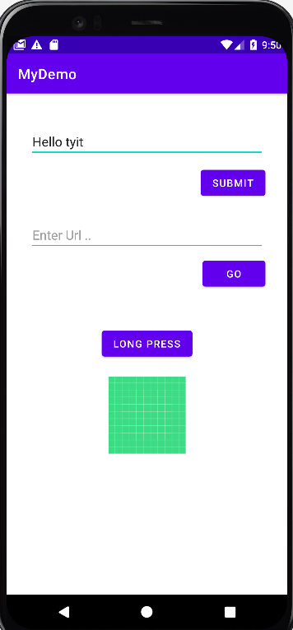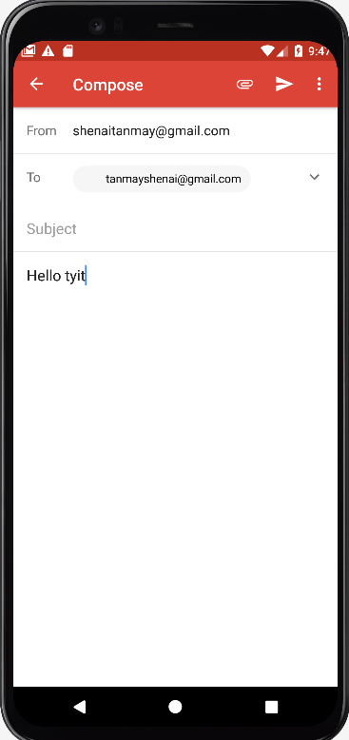

Enter Key Event & Long click event :
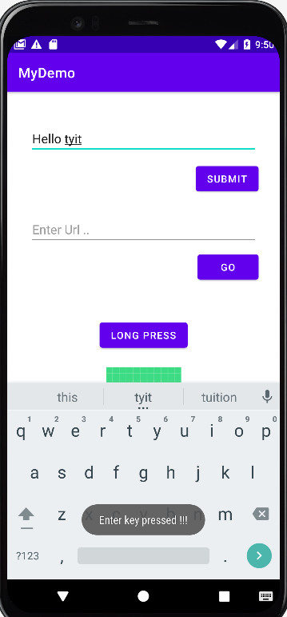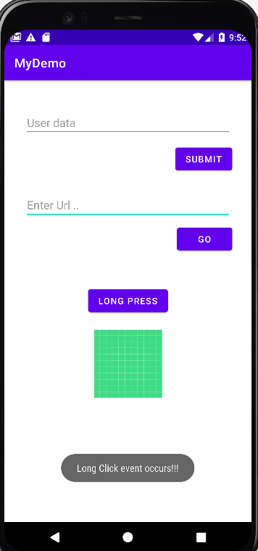

Outside an Application(Intent)
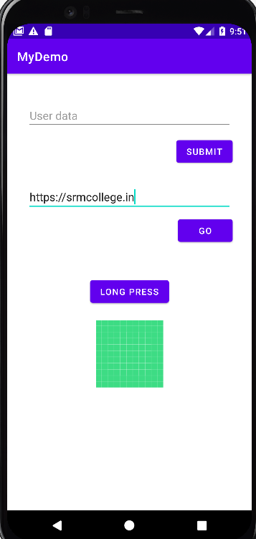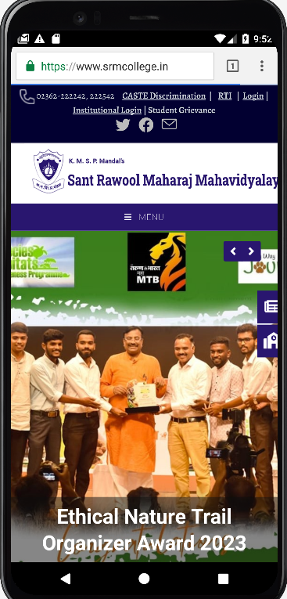

TouchListener-Action_down & Action_up :
